**Soarain ADT to Pyxis**

**V1.1**

**Prepared By: Stephen Mattei**

**Date: 8/8/2019**

Document Control 3

Resources: (include Project Team Members, Liaisons, Vendor Contacts, etc.) 3

Project Distribution List 3

Document Version Control 3

1. Introduction 4

1.1 Purpose 4

1.2 Project Scope 4

1.3 Terminology Standards 4

1.3.1 Acronyms 4

1.3.2 Glossary 4

1.4 Document References 4

2. Diagram 5

3. Requirements 6

3.1 Functional Requirements 6

3.2 Non-Functional Requirements 6

3.3 Messaging Protocols 7

3.3.1 Inbound to the BayCare Cloverleaf 7

3.3.2 Outbound to the Vendor 7

4. HL7 Messaging 8

4.1 Messaging Format 8

4.1.1 Segments 8

4.1*.*2 Messaging Event Types 9

4.1*.*3 Cloverleaf Configuration Files 9

4.1.4 Cloverleaf Site Location 9

4.2 Data Transformation Requirements 10

4.3 Sample Message 11

5. Alerts 11

Appendix A: Risks and Concerns 11

Appendix B: Issues List 12

# **Document Control**

## Resources: (include Project Team Members, Liaisons, Vendor Contacts, etc.)

|  |  |  |
| --- | --- | --- |
| **Name** | **Role** | **Email** |
|  |  |  |
|  |  |  |
|  |  |  |
|  |  |  |
|  |  |  |
|  |  |  |
|  |  |  |
|  |  |  |

## Project Distribution List

## Document Version Control

|  |  |  |  |
| --- | --- | --- | --- |
| **Version** | **Date** | **Modifier** | **Description** |
| V1.0 | 12/7/2017 | Stephen Mattei | Originally Created |
| V1.1 | 08/8/2019 | Charles Markwardt | Updated Diagram |
|  |  |  |  |
|  |  |  |  |

# 1. Introduction

## 1.1 Purpose

The Purpose of this document is to define the functional and nonfunctional requirements for the Soarian to Pyxis ADT interface.

* Specifies the requirements to be included in the technical design and build of the Pyxis ADT interface
* Defines the Cloverleaf mapping requirements to support the solution
* Defines source and destination protocols as well as connectivity data
* Creates a detailed description of the business logic associated with the stored procedure and defines field length, field data types, and order of fields as wells as the stored procedure’s name.

As is true with any requirements specification, this document may be modified, subject to developments in technology, changes to the standards, or new business requirements.

## 1.2 Project Scope

Pyxis is the enterprise wide pharmacy system for all acute care facilities. This ADT interface is designed to provide Pyxis with the required patient demographic information.

## 1.3 Terminology Standards

### 1.3.1 Acronyms

Define the acronyms and their associated definitions used in this document. The acronyms should be listed in alphabetical order.

### 1.3.2 Glossary

List the terms that require definition with respect to Cloverleaf and the product whose requirements are defined in this document. The definitions are specific to this document and may not be identical to the definitions of these terms in common use.

## 1.4 Document References

List all documents or Web addresses to which this IDBB refers; provide enough information so that the reader can access a copy of each reference. Include the title, author, version number, date, and source or location.

# 2. Diagram

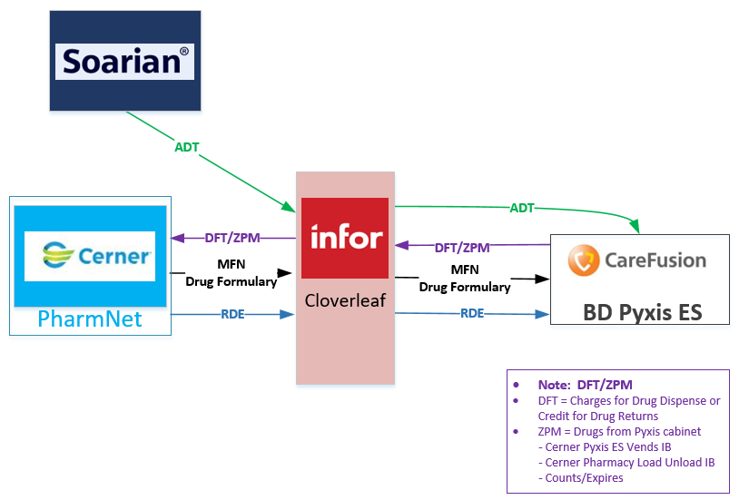

# 3. Requirements

## 3.1 Functional Requirements

Provide detail for the below functional requirements. The message transformation requirements for the components defined in this specification should be specified in section 4.2 of this document.

|  |  |  |
| --- | --- | --- |
| **Cloverleaf** |  |  |
| **Number** | **Requirement Name** | **Requirement Description** |
| FR.2017.1.0 | Message header | Insure that the messages header conforms to expectations of the receiving system, Pyxis. |
| FR.2017.2.0 | Paitent Location: Outpatient and ED | If the patient is an outpatient or emergency department patient and there is not location data in PV1:3.0 reference the encounter location code in PV1:39 and insert the two character encounter location suffix in PV1:3.0 |
| FR.2017.2.1 | Patient Location: Inpatient and status of scheduled | IF the patient is an inpatient and has a status of scheduled in PV2:24, patient status code, copy PRAD into PV1:3.0 |
| FR.2017.3.0 | Discharge Date | Insure that if an A03, patient discharge, is received that there is a date in PV1:45. If there is no date then place the message date and time in PV1:45 |
| FR.2017.3.0 | Filter Outpatient and ED A08 | If MSH:9 is ADT^A08 and PV1:2 is either O or E filter the message from going to Pyxis |
| FR.2017.3.1 | Filter ED Discharges | If MSH:9 is ADT^A03 and PV1:2 is E filter the message from going to Pyxis |
|  |  |  |

## 3.2 Non-Functional Requirements

Provide concise detail for the below non-functional requirements. This would include external table ownership, hours of support, etc. The below requirements must be evaluated for every project.

|  |  |  |
| --- | --- | --- |
| **Cloverleaf** |  |  |
| **Number** | **Requirement Name** | **Requirement Description** |
| NFR.20XX.1.0 | Click here to enter text. | Click here to enter text. |

## 3.3 Messaging Protocols

Below are listed the details for the messaging protocols that will be leveraged for this integration. This includes: TCP/IP, FTP, Web Services, etc.

### 3.3.1 Inbound to the BayCare Cloverleaf

|  |  |
| --- | --- |
| FTP |  |
| MLLP Socket Connection (TCP/IP) |  |
| Local File Drop by Midrange Team |  |
| Other | Click here to enter text. |

### 3.3.2 Outbound to the Vendor

|  |  |
| --- | --- |
| FTP |  |
| MLLP Socket Connection (TCP/IP) |  |
| Local File Drop by Midrange Team |  |
| Other | Click here to enter text. |

# 4. HL7 Messaging

## 4.1 Messaging Format

### 4.1.1 Segments

The segments utilized for this interface are:

MSH

EVN

PID

[PV1]

*Message Construction Notes:*

*[Square Brackets] – Optional*

*{Curly Brackets} – Repeatable*

*MSH – Message Header*

*EVN – Event segment*

*PID – Patient ID segment*

*PV1 – Patient Visit segment*

*[{ – Start of optional, repeatable group*

*}] – End of optional, repeatable group*

### 4.1*.*2 Messaging Event Types

Below are the messages types necessary for this integration

|  |  |
| --- | --- |
| **Event Type** | **Description** |
| A01 | Admit Patient |
| A02 | Transfer Patient |
| A03 | Discharge Patient |
| A04 | Register Patient |
| A05 | Pre-Admit Patient |
| A06 | Outpatient to Inpatient |
| A07 | Inpatient to Out |
| A08 | Update Patient Information |
| A09 | Patient Departing |
| A10 | Patient Arriving |
| A11 | Cancel Admit |
| A13 | Cancel Discharge |
| A32 | Cancel Patient Arriving |

### 4.1*.*3 Cloverleaf Configuration Files

Soarf_pyxises_adt.xlt

### 4.1.4 Cloverleaf Site Location

Pharmacy_17

## 4.2 Data Transformation Requirements

| **Field Description** | **HL7 Field Loc.** | **Required Y/N** | **Notes** |
| --- | --- | --- | --- |
| Sending Application | MSH:3 | Y | Hard coded “Soarian-FN” |
| Mesasge Control ID | MSH:10 | Y | Characters 5 through 8 are pulled from the original message control ID then they are concatenated with: message date and time MSH:7, Paitent status code PV2:24, and patient type, PV1:18 |
| Receiving Application | MSH:5 | Y | Hard coded “PYXIS” |
| Receiving Facility | MSH:6 | Y | Hard coded “PYX-2000” |
| Version ID | MSH:12 | Y | Hard coded “2.2” |
| **Remaining MSH** | MSH:* |  | All other MSH fields sent as is without modification |
| Paitent ID “CPI” | PID:2 | Y | Patient CPI |
| Patient ID List “MRN” | PID:3 | Y | Soarian MRN |
| Patient Name | PID:5 | Y |  |
| Patient DOB | PID:7 | Y | Date of birth |
| Patient Sex | PID:8 | Y |  |
| Patient Acount Number | PID:18 | Y | Patient FIN |
| Patient SSN | PID:19 | N |  |
| Patient Class | PV1:2 | Y |  |
| Patient Location | PV1:3 | Y |  |
| Patient Location Point of Care | PV1:3.1 | Y | If O or E and PV1:3.1 is blank copy concatenated PV1:10 and encounter location suffic derived from PV1:39 and table soarF_enctr_loc_suffix.tbl.  If PV2:24 equals scheduled and PV1:2 equals I then copy PRAD to PV1:3.0 |
| Location Status | PV1:3.4 | N | MSH:4, Sending Facility, is copied into this field |
| Prior Patient Location | PV1:6 | N |  |
| Patient Type | PV1:18 | N |  |
| Patient Admit Date | PV1:44 | N |  |
| Paitent Discharge Date | PV1:45 |  | If it is an A03 and there is no discharge date then copy the message date and time into the discharge date field. |

## 4.3 Sample Message

MSH|^~\&|Soarian-FN|SJS|PYXIS|PYX-2000 ADT|201712070756||ADT^A04|b912-98201712070756Checked inE|P|2.2||1EVN|A04|201712070756||CIPID||810016093|7000016776^^^BCH||MATNEYTEST^PHARMACYJS||19821125|F||||||||||6000036116^^^BCHS^VCPV1||E|ERDSH^^^SJS|||||||||||||||E||||||||||||||||||||||||||201712040753

# 5. Alerts

Are you going to need alerting on this connection?

|  |  |
| --- | --- |
| Yes |  |
| No |  |

If the answer is yes, please complete the table below:

|  |  |  |  |
| --- | --- | --- | --- |
| **Site Name** | **Hours of Support** | **Distribution Group** | **Comments** |
|  |  |  |  |
|  |  |  |  |

# Appendix A: Risks and Concerns

|  |  |  |  |  |  |  |  |  |
| --- | --- | --- | --- | --- | --- | --- | --- | --- |
| **Project Name** |  |  | | |  |  |  |  |
| **Number** | **Risk / Concern** | **Comment** | **Mitigation** | | |  |  |  |
| RC.2013.1.0 |  |  | |  | |  |  |  |

# Appendix B: Issues List

This is a dynamic list of the open issues related to the IDBB that remain to be solved, including but not limited to TBDs, pending decisions, information needed, conflict awaiting resolution, and the like.

|  |  |  |  |  |  |  |  |  |
| --- | --- | --- | --- | --- | --- | --- | --- | --- |
| **Project Name** |  |  | | |  |  |  |  |
| **Number** | **Issue** | **Comment** | **Fix** | | |  |  |  |
| I.2013.1.0 |  |  | |  | |  |  |  |

* End of document